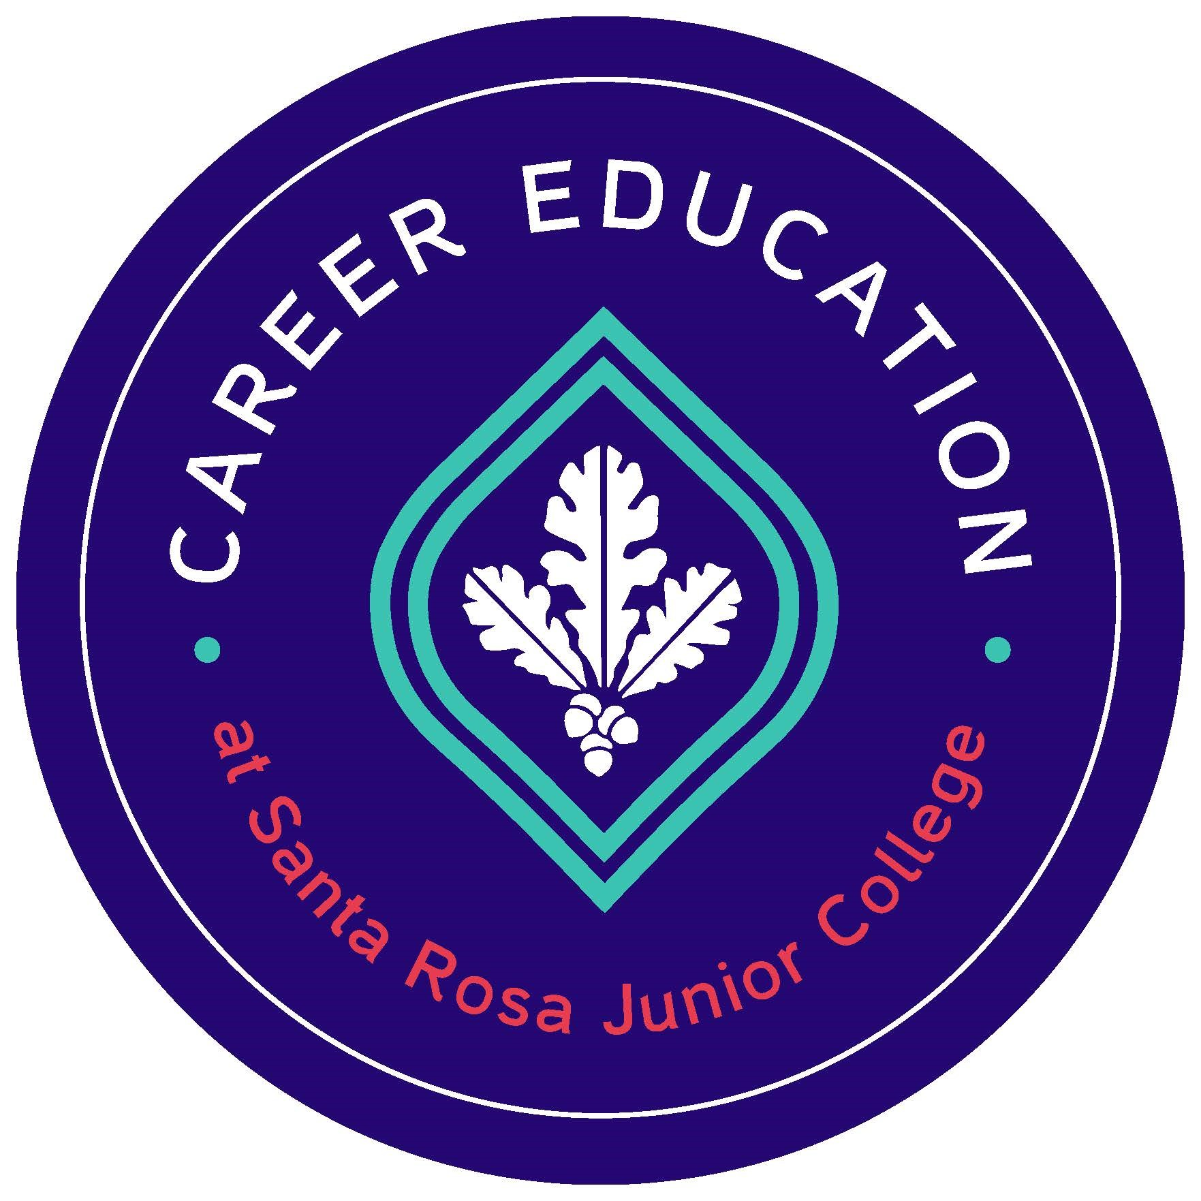
2021-2022 PROFESSIONAL DEVELOPMENT
MINI GRANT SUMMARY

Date:

Submitters Name:

Department/Program:

Title of Project:

- Please describe the outcomes from this activity. (Limited to 1,000 characters)

- Describe how this activity improves your program. Please be specific. (Limited to 1,000 characters)
Examples: increase student recruitment and the number of completers, meeting student learning outcomes, strengthening the knowledge, ability and skills of the career and technical students, providing students with a strong experience in and understanding all aspects of an industry, incorporate work-based learning experiences with in the curriculum.

Please submit an electronic copy of the Mini-Grant Summary to Rachel Smith rsmith@santarosa.edu

