**2024-2025 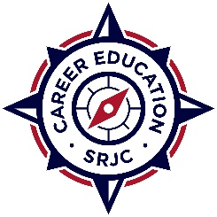PERKINS PROFESSIONAL DEVELOPMENT**

**MINI GRANT REPORT**

Submit completed report by email to [rsmith@santarosa.edu](mailto:rsmith@santarosa.edu)

Date:

Submitters Name:

Department/Program:

Title of Training:

1. Describe what you learned from this training
2. Describe how your participation in this training will improves your program(s). Please be specific.

Examples: increase student recruitment and the number of completers, meeting student learning outcomes, strengthening the knowledge, ability and skills of the career and technical students, providing students with a strong experience in and understanding all aspects of an industry, incorporate work-based learning experiences with in the curriculum.