**2025-2026 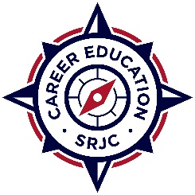PROFESSIONAL DEVELOPMENT**

**MINI GRANT APPLICATION**

Submit completed application by email to [rsmith@santarosa.edu](mailto:rsmith@santarosa.edu)

Email submission must include supervising administrator’s support of application and verification that the training is related to Career Education teaching assignments

Submitter’s Name:

Department/Program:

Title of Training:

Date of Training:

Out of State Travel?

Out of State Travel will require additional approval (takes 2-4 weeks; do not book anything prior to approval)

Amount Requested:

Not to Exceed $2,000

TOP Code(s): (use 6 digit) [Use this link](https://www.cccco.edu/-/media/CCCCO-Website/docs/curriculum/final-top-code-manual-2023edit-4-a11y.pdf) to determine TOP Code for your program:

Fall 2024 Advisory Meeting Date **with a quorum**: ❑ Did not meet in Fall 2024

Spring 2025 Advisory Meeting Date **with a quorum**: ❑ Did not meet in Spring 2025

Attach documentation, such as a course flyer

1. Describe the requested professional development activity and how it benefits the objectives of the program (department)
2. Describe how this activity is focused on improving student success and addresses recommendations of the [Strong Workforce Task Force.](https://www.cccco.edu/About-Us/Chancellors-Office/Divisions/Workforce-and-Economic-Development/Strong-Workforce-Program/COB)