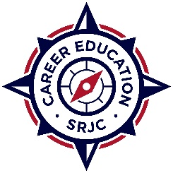
2026-27 PROFESSIONAL DEVELOPMENT
MINI GRANT APPLICATION

Submit completed application by email to rsmith@santarosa.edu
Email submission must include supervising administrator’s statement of application support and verification that the training is directly related to Career Education teaching assignments

Submitter’s Name:

Department/Program:

Title of Training:

Date of Training:

Location of Travel:
Out of State Travel will require additional approval (takes 2-4 weeks; do not book anything prior to approval)

Amount Requested:
Not to Exceed $2,000

TOP Code(s): (use 6 digit) Use this link to determine TOP Code for your program:

Fall 2025 Advisory Meeting Date with a quorum: Did not meet in Fall 2025

Spring 2026 Advisory Meeting Date with a quorum: Did not meet in Spring 2026

Required: Attach documentation, such as a course flyer

- Describe the professional development activity and how it benefits objectives of the program

- Describe how this activity is focused on improving student success and addresses specific recommendations of the Strong Workforce Task Force.

