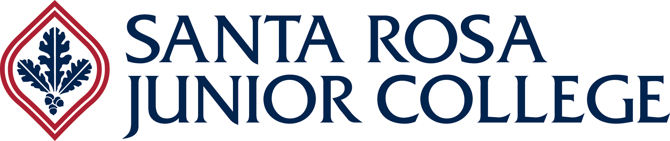 Department of Health Science

**Agenda  
Allied Dental Education - Advisory Committee Meeting  
6:00-7:00pm  
Wednesday, October 16, 2024**

**Via Zoom**

The primary purpose of the advisory committee is to assist and provide recommendations to the district in establishing, operating, and evaluating programs that serve the needs of student’s, business, and industry and to provide expertise pertaining to technological and subject matter changes. The advisory committee provides a mutual exchange of information for program improvement.

1. Call to Order (Committee Chair) Dr. Mark Frey
2. Welcome/Introductions All
3. Approval of Minutes from Last Meeting (10/19/23) All
4. Public Comments
5. Unfinished Business
6. New Business, Department Updates

DHI Fall 2024 Enrollment, Demographics Cindy F.

DA Enrollment, Demographics Andrea E.

DHII Updates Jennifer A-K

1. Discussion Items: Advisory Committee Members

We value your input as we continue to refine and revise our curriculum to meet the needs of the profession and provide the most appropriate and current education for our future Dental Programs graduates. Discussion:

**Jennifer Apocotos-Kirk:**

Is the NOMAD portable X-ray currently being used in your dental practice, and if so, what has been your experience with its effectiveness and practicality in everyday patient care?

Recently the students have been introduced to the Piezo scaler.  Does your office offer both forms of power scaling, ultrasonic and piezo?

**Susan Hellums**

What are the preferred x-ray receptor holders used among your employees when taking radiographs? (Both BWX and FMX)

What do you find new graduates needing improvement on as far as taking diagnostic radiographs and is there a common pattern you notice among that need?

**Andrea Emerson**

Recently, I attended a meeting about upcoming DBC changes aimed at expanding the scope of practice for RDAs, which is great news. However, there is no increase in the time allocated for DA educators to teach these new skills. As I reassess the time required for introducing new clinical competencies, I’d like to gather your insights on the following:

Which materials do you think the students are not familiar with or need more practice with before starting their internships?

Are your offices moving away from using alginate impressions? If so, what alternative materials are being adopted (e.g. AlgiNot or CAD/CAM)?

**Cindy Fleckner:**

What are your thoughts about the possibility of the Dental Hygiene Program at SRJC becoming a bachelor’s degree program in the future?

1. Dean’s Report – Tammy S.

**SAVE THE DATE – NEXT ADVISORY COMMITTEE MEETING** - October 8th, 2025

Adjournment