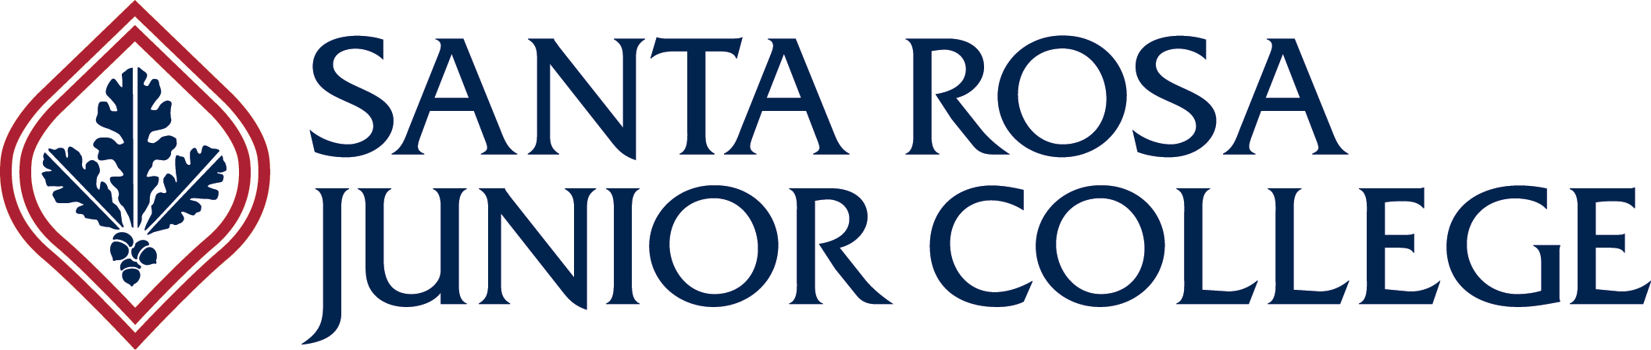 Department of Health Science

**Allied Dental Education**

**Advisory Committee Meeting Minutes  
6:00-7:00pm  
Wednesday, October 16, 2024**

**Via Zoom**

**Members Present:**

**Mark Frey, Darin Schettler, Jennifer Borg, Kailena Coletti de Alcuaz, Kathy Kane, Katrina Morris, Christine Ford, Jessica Chen, Jessica Wong**

**Quorum was met**

**Members Absent:**

**Gwen Essex**

The primary purpose of the advisory committee is to assist and provide recommendations to the district in establishing, operating, and evaluating programs that serve the needs of student’s, business, and industry and to provide expertise pertaining to technological and subject matter changes. The advisory committee provides a mutual exchange of information for program improvement.

1. Call to Order (Committee Chair) Dr. Mark Frey
2. Welcome/Introductions-

**We welcomed Andrea Emerson as our new Allied Dental Full-time faculty, as she replaced Jennifer Poovey who retired. Also we are very happy to have Jennifer Borg, RDAEF join our advisory committee member team.**

1. Approval of Minutes from Last Meeting (10/19/23) **Approved**
2. Public Comments **None**
3. Unfinished Business **None**
4. New Business, Department Updates

**Cindy reported outcome of CODA site visit. We have approval without reporting requirements, until 2030 next site visit.**

**DHI Fall 2024 Enrollment, Demographics Cindy F**

**155 Applicants, 114 qualified for lottery. We started with 24 DH students, 2 students dropped 3-4 weeks into the program. It was too late to get a student on the alternate list. The majority age range is 24-29(10), 5 are 23 and under, 6 are 30-34, and 1 is 35-39. 19 Females, 3 Males, Level of education-18 out of the 22 have AS or BS degrees. 9 Students reported that they work while taking the program(8-30 hours per week). 18 are planning on staying in Sonoma County, 3 in Marin, and 1 in Solano county**

**DA Enrollment, Demographics Andrea E.**

**46 Applicants, 44 qualified for lottery. 23 DA students, 22 F and 1 other, the majority are age 23-under, 3 are 24-29 and 1 is 35-39 years old.1 student reported working as a sterilization assistant and dental receptionist. 14 students in total work from 15-30 hours a week. Level of education 9 students with an HS diploma, 1 has a bachelor's degree, and 2 have associate degrees.11 students are Spanish-speaking.17 of the 23 students plan on staying in Sonoma Couty and 2 will remain in Napa after graduation.**

DHII Updates Jennifer A-K

**24 students. Same demographics that Cindy reported at the last advisory meeting.  Students are working hard to fulfill requirements.  Dr. Ngyuen has been sending patients to our clinic who have been periodontally involved and a great challenge to the students.**

1. Discussion Items: Advisory Committee Members

We value your input as we continue to refine and revise our curriculum to meet the needs of the profession and provide the most appropriate and current education for our future Dental Programs graduates. Discussion:

**Jennifer Apocotos-Kirk:**

Is the NOMAD portable X-ray currently being used in your dental practice, and if so, what has been your experience with its effectiveness and practicality in everyday patient care

**Drs. Frey and Schettler do not use a NOMAD portable x-ray.  They have seen it in endodontist or surgical settings only.**

**Dr. Ford does have a NOMAD, but due to office staff changing tube heads and settings she has not been pleased with the results.**

Recently the students have been introduced to the Piezo scaler.  Does your office offer both forms of power scaling, ultrasonic and piezo?

**All RDH's on advisory committee use only the USS.  Drs. Frey and Schettler use USS in their offices only.  Dr. Ford has both Piezo and USS and finds that the brand she has tends to be less effective. (EMS?)**

**Susan Hellums**

What are the preferred x-ray receptor holders used among your employees when taking radiographs? (Both BWX and FMX)

**Most members expressed that their offices primarily use the Rinn receptor holder system. While the majority utilize the complete ring system, one RDAEF mentioned using only the bite block from the Rinn kit. She believes the ring does not provide sufficient accuracy and recommends focusing on patient anatomy instead.**

What do you find new graduates needing improvement on as far as taking diagnostic radiographs and is there a common pattern you notice among that need?

**The group reached a consensus that students should become proficient in taking vertical bitewings (BWX). Dr. Ford, a periodontist, exclusively accepts vertical bitewings in her practice. Dr. Schettler consistently refers his patients to our clinic for X-rays but has recently observed an increase in non-diagnostic films being sent back to his office. Many of these images are lacking diagnostic quality due to missing apices. He wants to ensure that only clinically diagnostic films are returned to his office.**

**Andrea Emerson**

Recently, I attended a meeting about upcoming DBC changes aimed at expanding the scope of practice for RDAs, which is great news. However, there is no increase in the time allocated for DA educators to teach these new skills. As I reassess the time required for introducing new clinical competencies, I’d like to gather your insights on the following:

Which materials do you think the students are not familiar with or need more practice with before starting their internships?

**Due to the broad range of materials used in different offices, the consensus was to keep to basic skills development. Familiarize students with different mixing techniques for dental cement since some offices still use hand mixing; however, more offices are using expressed materials that do not require mixing.**

Are your offices moving away from using alginate impressions? If so, what alternative materials are being adopted (e.g. AlgiNot or CAD/CAM)?

**Some offices still use alginate. Some offices are using expressed materials for a more consistent mix. Other offices have moved into intraoral scanning, eliminating the need for alginate impressions. SRJC DA program covers all of these techniques.**

**Cindy Fleckner:**

What are your thoughts about the possibility of the Dental Hygiene Program at SRJC becoming a bachelor’s degree program in the future?

**We had the Discussion regarding how “Bachelor programs in community colleges” have been gaining prominence, particularly in fields like Dental Hygiene.**

**All the comments were “Pro” from the advisory team.**

**One pro that was discussed was “Career Advancement Opportunities”- Obtaining a bachelor’s degree in Dental Hygiene opens up greater career advancement opportunities, such as roles in education, management and research.**

**Dr. Ford stated that she has seen a difference in her employees with a DH bachelor’s degree versus associate degree.**

Dean’s Report – Tammy S.-**Overall, the evolving landscape of bachelor programs in community colleges, particularly in Dental Hygiene, reflects a shift toward higher education. This trend is likely to continue as community colleges adapt to the needs of students and the healthcare industry.**

**SAVE THE DATE – NEXT ADVISORY COMMITTEE MEETING** - **October 8th, 2025**

Adjournment -**7:01PM**