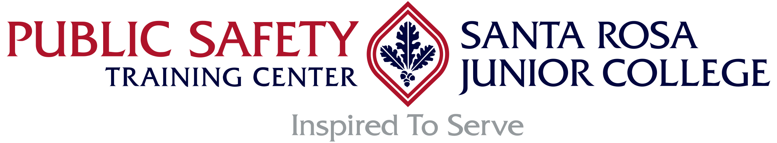

Law Enforcement Advisory Committee Meeting – Agenda

Date: October 8th, 2024; Tuesday, 10:30 am
Place: Public Safety Training Center, Conference Room
(With a Zoom Option) Zoom will be sent out later.

Zoom Details:

1030 Call to Order – Chief Mattos
Welcome and Introductions

1035 Approval of Minutes from May 2024 Meeting – Chief Mattos
Announcements – All
Public Comments: Regarding College-Related Issues not Appearing on this Agenda – Chief Mattos

1040 Unfinished Committee Business – Chief Mattos/All

1045 Basic Police Academy Overview and Update – Director Potter
- BPA 215
- BPA 216 Update on Reservations
- Overview of BPA reservation process moving forward – commitment to our region as a priority

1100 In-Service Training Update and Overview – Director Potter and Tony Carrancho
- Schedule of Classes
- Training Updates –
  - Dispatch Academy Update for 2025 (3 presentations possible); Actively recruiting for Instructors
  - PSP Classes
  - Updates - Firearms Instructor; Requalification Course

1115 Round Table – All

Next Meeting Date – May 6th, 2025 at 1030 hours.
- Location – to be determined.

Adjournment – Chief Mattos

